AWD Peer Review Guidelines

Peer review is an essential part of the writing and revising process. Not only will it serve as an indispensable tool in producing final drafts for this classroom, but also mastery of this process will help bolster your rhetorical awareness. You will find that the more you peer review, the more you will learn about your own writing. An effective peer review is designed to help the author of a project think through the difficult challenges of the subject, while helping the writer learn about his/her own strengths, challenges, and processes. You will find that the more you peer review, the more you will learn about your own writing. An effective peer review is designed to help the author of a project think through the difficult challenges of the subject, while helping the writer learn about his/her own strengths, challenges, and processes.

Directions. While reviewing your partner’s paper, make in-line comments as necessary (see documentation below). When you are finished reading (or as you read), complete a peer review report according to the outline below. Include this in a <report> element on your partner’s XML file (see documentation below).

Read your partner’s work and write an approximately 250-400 word review that contains the following sections:

Summary. Your 1-2 sentences should summarize, without evaluating, the draft you are reviewing. You want to ensure, both to yourself and to the author, that you understand the draft completely. This helps the author trust your judgment later, and it may also help the author to determine if they are effectively communicating their message. This section will be very short, but should include your understanding of the rhetorical situation the author is responding to.

Critique. The bulk of your review should consist of a critique of the major aspects of the paper. Unlike during the summary portion of the assignment, this is where you evaluate. Therefore, constructive critique is often more valuable than praise, but of course pointing out specific places that are working well is helpful (so long as you can explain why, which is the helpful part). I offer the following three-part process for each element you want to critique:

• Identify what it is you are critiquing. Name the aspect of the piece of writing (such as language, organization, rhetorical effectiveness, brevity...) and an example of where the writer’s use of this aspect could use work. Be specific. Quote or reference a particular paragraph, sentence, or section.

• Evaluate what you have identified and explain your critique as best as you are able. Your peer will be more likely to seriously consider your advice if it is specific. If you just say that their argument is not working, they might shrug it off or think you do not understand what they are trying to do. However, if you take the time to explain that the evidence doesn’t support the claim, then they might start to see where you are coming from. Just like any other good piece of writing, a peer review requires a well- developed argument. Once again, use quotes from the writer’s text.

• Advise how the writer might revise. Don’t just leave them with what is not working in the piece. Think positive! Give them some clear advice on how to improve the aspect you are critiquing. How can the writer rewrite, rearrange, or rethink? This is where the collaborative nature of peer review comes into play. Remember, in a writing community

Here are some questions to help you generate responses to your partner’s work:

- How appropriate is this genre for the rhetorical situation the writer is responding to? Is the rhetorical situation clear?
- As an expert in the genre, are the author’s sentence and word-level choices appropriate for this genre?
- Are there aspects of the genre (particular rhetorical moves, design elements, jargon, etc.) that the author does not take up?
- How can this composition be positioned to be more successful in this given rhetorical situation?
- Does the composition reflect the research into the genre your group has completed?
- How well is the author conforming to the rules of the schema?

Peer Review documentation
- Update (sync) your local folder.
- Find your peer review partner’s document in your local repository
- Make inline comments with: <note type=“peer” resp=“#[your_id]”>text of comment</note> (see example below).

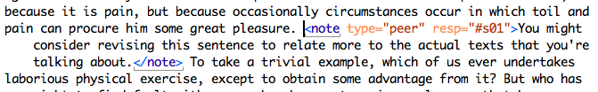

- Use <reviewer> element with the @type and @xml:id attributes (see below).
- Write your peer review report in a <report> element in the <docReview> section of your partner’s document. Be sure to use the @type= “peer” attribute and the @resp= “#[your_id]” (see below).

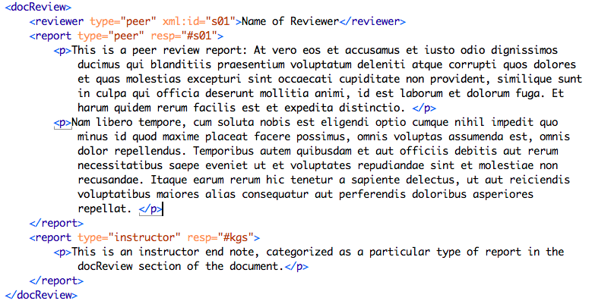

- Save the file normally (DO NOT CHANGE THE FILENAME).
- When you complete your report, push your changes to the remote repository (commit to master) with a commit message and sync your folder.

you are not just responsible for producing your own best work, but also helping your peers to do the same.

Feelings and Grammar

There are two very important issues when it comes to peer reviewing that I have not mentioned above, but that deserve to be addressed.

First of all, I know that sharing your work with others can be uncomfortable and anxiety inducing at first. A thoughtful, kind, and supportive community can help alleviate that discomfort and become the most important tool you have as a writer. I ask that everyone offer their critiques in the spirit of collaboration. In your written peer reviews and in the workshop discussions, follow the golden rule: treat the writing of others as you would like your own writing to be treated.

Finally, I would like to point out that I am asking you to work as reviewers of your peers’ work, not as editors. Reviewers typically take global issues of revision into account— issues like argument, organization, clarity, introductions and conclusions, and overall rhetorical effectiveness—while editors focus on the more local issues that are taken care of in editing and proofreading. It is important that you understand the differences between these processes.

